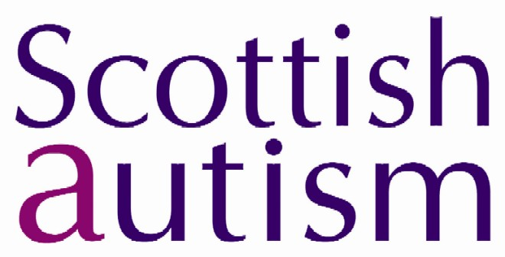
Subject Access Request Form under the Data Protection Act 1998

Notes for Applicants

- Under the Data Protection Act, individuals have the right to access data held about them under a subject access request.
- If you are applying on your own behalf you need only complete Sections 1, 4 & 5.
- If you are applying on behalf of someone else you must complete all the Sections.
- Everyone making an application must complete Section 1.
- Please complete all sections in BLOCK CAPITALS.

SECTION 1: Your Details
What information are you requesting?

Surname
Forename(s)
Maiden Name (if applicable)
Age (if under 18)
Address
Postcode
Daytime phone number
Email address

SECTION 2: Details of the data subject (if you are applying on behalf of another person)
His/Her Title
His/Her Surname
His/Her Forename(s)
Her Maiden Name (if applicable)
His/Her Age (if under 18)
His/Her Address
His/Her Postcode
Daytime phone number
His/Her Email address

SECTION 3: Permission from the Data Subject
Please complete one of the following:

EITHER
I have a letter from the person who is named in Section 2 authorising me to apply on his/her behalf and enclose the letter, dated ______________, which I enclose with this subject access request form

OR
My relationship to the person I have named in Section 2 is (e.g. Parent or Guardian)

I am entitled to act on behalf of that person because

SECTION 4: Information to enable us to do the search
Give any information you think may help us to complete the search. It will help us to know details such as the service area, manager’s name etc.

What contact does the data subject have with Scottish Autism?
(e.g. service user, parent, employee etc)

Which region/ service does the data subject have contact with? (Please give dates if possible)

SECTION 5: Declaration
Please read this section carefully, then sign and date it at the bottom

- I understand that the 40 day period in which Scottish Autism must respond will not start until I have provided sufficient information to make the search.
- I understand that I must provide proof of identity (e.g. passport, driving licence) before the request is processed.
- I understand that Scottish Autism may contact me for further information in relation to this request.
- I understand that the search may show that Scottish Autism does not hold any personal data about me, or the person on whose behalf I am applying.
- If information held about the data subject also contains information about other people (third party), and Scottish Autism cannot provide the data requested without disclosing information that would identify that third party, the information does not need to be disclosed, unless permission has been sought and given by the third party.

I certify that I am the person in SECTION 1
Signed
Date

Please complete all relevant sections of the form and return it with your letter of authorisation (if applicable – see Section 3) to:

The Information Governance Manager, Scottish Autism, Hilton House, Whins Road, ALLOA, FK10 3SA

