Lego®-based Therapy Workshop

For professionals working with people on the autistic spectrum (e.g. teachers, classroom assistants, play therapists, social workers).

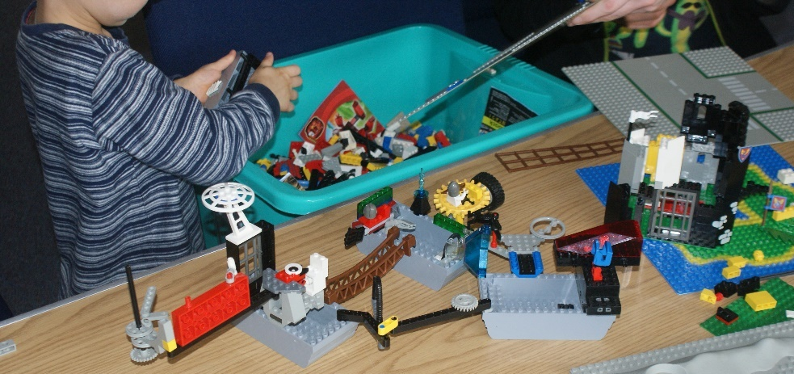

**Time** 9.45am to 12:30pm

**Date** Tuesday, 7th November, 2017

**Price** £60.00

**Location** Tesco Training Room, 7 Gavin’s Mill Road, Milngavie, G62 6NB

Research has shown that Lego®-based Therapy can help those on the autistic spectrum learn social skills. This workshop outlines the framework introduced by Daniel LeGoff and Gina Gomez de la Cuesta. June Grindley, our trainer, explains her own experience of successfully using this technique. This workshop will be interactive and includes time to practise what you learn.

**Booking Form**

Lego-based Therapy 7th November, 2017

To book:

* Email [june@creatovators.com](mailto:june@creatovators.com) with details as below or,
* Complete and return the booking form below.

Please pay by cheque or online. Cheques should be made payable to “Creatovators CIC”, and sent to 13 Drumbeg Terrace, Milngavie, G62 7RH. If paying online please contact June Grindley for details.

If you would prefer, you can pay a non-returnable deposit of £10.00 and the balance on the day.

Name………………………………………...…………………………….

Address……………………………………………………………………

……………………………………………………………..…………….…

Postcode ………………………………

Email ………………………………………………………………………

Phone number………………………………….…………………………

Age and stage of children you work with …………………..

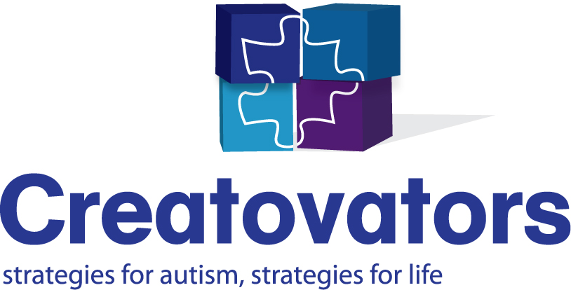We look forward to seeing you there.