Lego®-based Therapy Workshop
For parents and professionals working with people on the autistic spectrum (e.g. teachers, classroom assistants, play therapists, social workers).
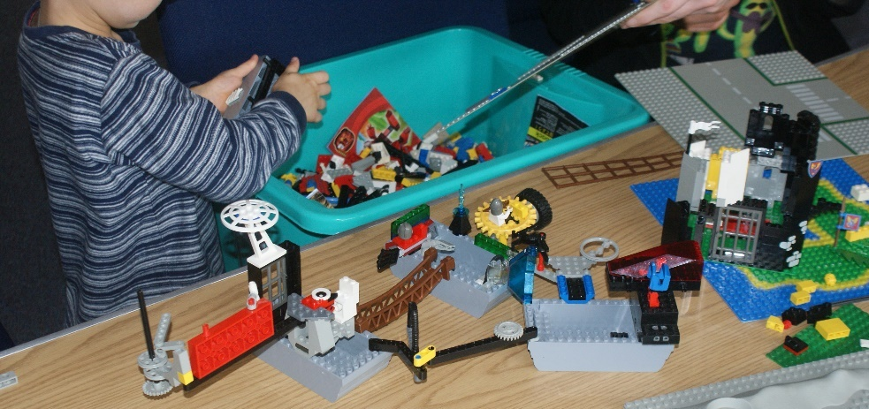

Time 9.45am to 12:30pm

Date Tuesday, 28th January, 2020

Price £80.00

Location Tesco Training Room, 7 Gavin’s Mill Road, Milngavie, G62 6NB

Research has shown that Lego®-based Therapy can help those on the autistic spectrum learn social skills. This workshop outlines the framework introduced by Daniel LeGoff and Gina Gomez de la Cuesta. June Grindley, our trainer, explains her own experience of successfully using this technique since 2010. This workshop will be interactive and includes time to practise what you learn.

Booking Form
Lego-based Therapy Tuesday, 28th Jan, 2020

NB: Places must be booked in advance and are subject to our Terms and Conditions which can be found at www.creatovators.com.

To book:
- Email june@creatovators.com with details as below or,
- Complete and return the booking form below.

Please pay by cheque or online. Cheques should be made payable to “Creatovators CIC”, and sent to 13 Drumbeg Terrace, Milngavie, G62 7RH. If paying by bank transfer please contact June Grindley for bank details.
Our privacy policy can be found at www.creatovators.com.

Name ………………………………………...……………………………

Address ………………………………………………………...…………

……………………………………………………………………...………

Postcode ………………………………

Email ………………………………………………………………………

Phone number………………………………….…………………………

Age and stage of children you work with …………………..

Signature ……………………………………….. Date …………………

