‘Powerful, moving, thought provoking (and with humour!)’ Feedback on the recent Autistic School Staff Project (ASSP) webinar highlighted the quality and perception of the contributions as well as the overwhelmingly positive message of the event.
Interest was high from the start. Sold out weeks in advance, 145 participants joined from across the UK and Ireland, and from as far afield as the USA and Australia. Attendees had diverse roles, and included Early Years practitioners, University Professors; Teaching Assistants and Head teachers; Educational Psychologists and Speech and Language Therapists; plus mentors, researchers, third sector workers, commissioners and more. It was also good to see a spread of both autistic (65) and non-autistic attendees (67), as well as people who worked in schools (66) and those who no longer did (43) or never had (25).
Professor Francesca Happé introduced four well-received presentations, starting with the project lead, Dr Rebecca Wood, who spoke about the ASSP team’s findings on autistic school staff and Covid-19. Pete Wharmby spoke passionately about the value of intense interests, before Claire O’Neill shared her thoughts on the strengths autistic people can bring to school leadership. Venessa Bobb, co-founder of A2ndVoice, completed the presentations with a powerful talk from her perspective as a black parent of autistic young people.
The following Q&A session featured a panel of autistic people who worked in various roles in schools, chaired by Dr Ruth Moyse. The panellists – Madge Woollard, Elkie Kammer, Jade Pitchford-Waters and Alan Morrison - offered brilliant insights on themes such as advice on revealing a diagnosis in the workplace, valuing ‘insider’ experiences, managing change and teacher training. One attendee commented:
‘Things are changing, and it's so good to hear someone say they want to recruit more autistic staff in schools.’
The panel’s excellent tips and recommendations will form part of a forthcoming project resource.
Engagement and discussions continued on Twitter, following live-tweeting from Dr Laura Crane. This resulted in impressive potential impressions of approximately 26K and a reach of 150K, plus comments such as this which encapsulated the aim of the project:
‘Inspirational hearing from other autistic teachers leading on inclusion issues and using their experience & expertise to educate other members of their school communities.’
The event was also beautifully encapsulated by an illustration by artist Sara Peeters, who incorporated the ASSP logo into her design:
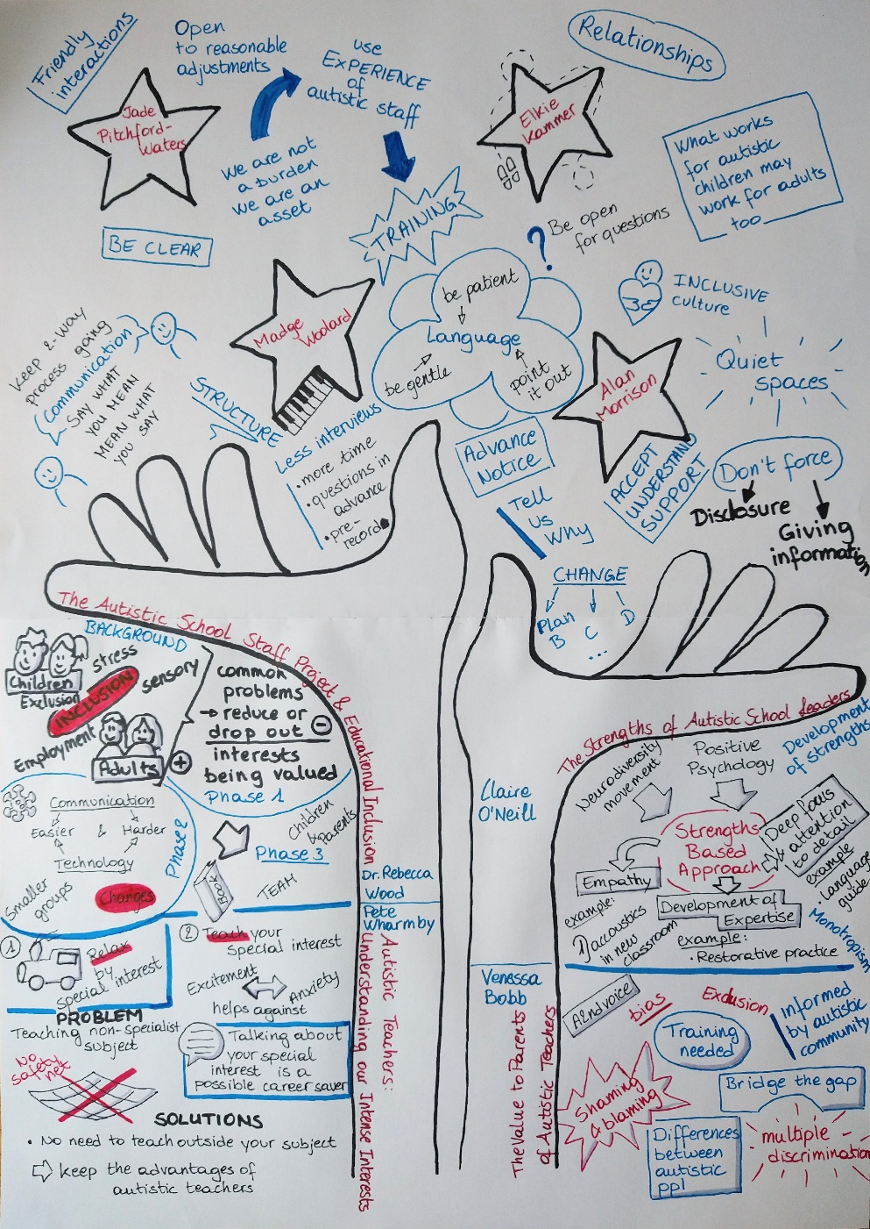
Catch up on the event by using the hashtag #AutSchoolStaff, following the project @AutSchoolStaff on Twitter and visit the website to read more about the team and their research Autistic School Staff Project – Helping to Facilitate Diversity and Inclusion in Schools
Dr Ruth Moyse and Dr Rebecca Wood.

Not all attendees completed the compulsory questions!

